|  |  |  |  |
| --- | --- | --- | --- |
| Student | Diego Andrés Montealegre García | Date | 03-03-2015 |
| Program | PSP 2.1 | Program # | 6 |
|  |  |  |  |

MODELO CONCEPTUAL

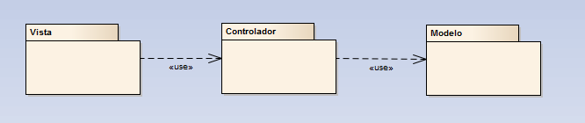

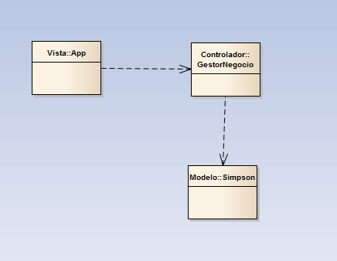

## Estructura

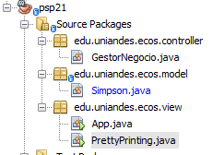

Modelo, se utiliza el mismo del taller PSP2.1, se le adiciona un constructor nuevo

1. Simpson(double, double)
2. AdjustD

